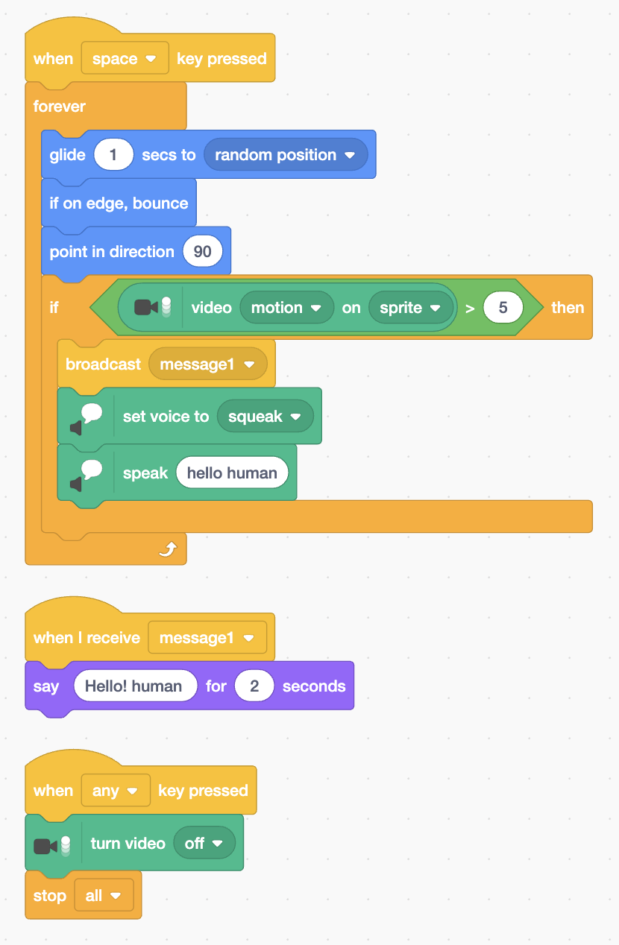

Create a Sprite
- On the bottom left click on <choose a sprite> option
- Select a sprite from the library or create your own

Sprite Movement
- Use the block when <when [space] pressed> to start the sprite movement
- Use <forever> block to make it continues.
- Place the <glide (1) secs to [random position]> block, so that the sprite will move smoothly to any random position on the stage.
- To avoid, the sprite to go partially out of the stage, use <if on edge,bounce> and <point in direction (90)> for preventing the rotation.

Movement Detection
- For the movement detection import the video sensing extension.
- Place <if then> block under the the above code inside the <forever> block.
- In the <if then> place greater than operator <( ) > (50)> with limit of 5 instead of 50.
- Now, place the <video(motion) on (sprite)> .
- The code will look like:
<if [ (video(motion) on (sprite)) > (5) ] then>

Make the sprite talk
- To make the sprite speak import the text-to-speech extension
- Place the block <broadcast(message1)> inside the <if then> block
- Under it place the <set voice to (squeak)> for the speech sound.
- Continued with place <speak (hello human)> to set what should be the out come of the speech.

To Print the text with Speech
- Place the block <when i receive message1>
- Under it place <say (hello human) for (2) seconds> to show the text
To Stop
- Place the <when [any] key pressed>
- Under it <turn video [off]>,to stop the video
- Continued with <stop all> for terminating the programme.

